**Date of Experiment: 10/01/25**

**Date of Submission: 24/01/25**

**SVKM’S NMIMS**

**Mukesh Patel School of Technology Management & Engineering**

Department of Mechatronics Engineering

**AR-VR Lab**

Subject- Robotic Process Automation

**EXPERIMENT NO. 1**

**Aim:**

The objective of this experiment is to assess the installation process and download efficiency of Power Automate Desktop, a robust automation tool developed by Microsoft. This experiment aims to provide insights into the installation process.

**Materials:**

1. Computer system with minimum requirements for Power Automate Desktop.

2. Internet connection.

3. Access to Microsoft's official website for Power Automate Desktop.

**Procedure:**

**1. Preparation:**

- Ensure that the computer system meets the minimum requirements specified by Microsoft for Power Automate Desktop.

- Connect the computer to a stable and reliable internet connection.

**2. Access Microsoft's Official Website:**

- Open a web browser and navigate to Microsoft's official website or the Power Automate Desktop product page.

**3. Navigation to Download Section:**

- Locate the download section on the website.

- Identify the correct version and edition of Power Automate Desktop that is suitable for your system.

**4. Initiate Download:**

- Click on the download link or button to start the download process.

- Monitor the download progress and note the time taken for the download to complete.

**5. Installation:**

- Once the download is complete, initiate the installation process.

- Follow the installation wizard, providing any necessary information and configuring settings as required.

- Document the time taken for the installation process to finish.

**6. User Experience Evaluation:**

- Assess the user interface and clarity of instructions provided during the installation.

- Note any issues or difficulties encountered during the installation process.

- Evaluate the user-friendliness of the software.

**7. Verification and Testing:**

- After installation, launch Power Automate Desktop to ensure that it functions as expected.

- Create a simple automation task to test the software's capabilities.

- Document any issues faced during the verification and testing phase.

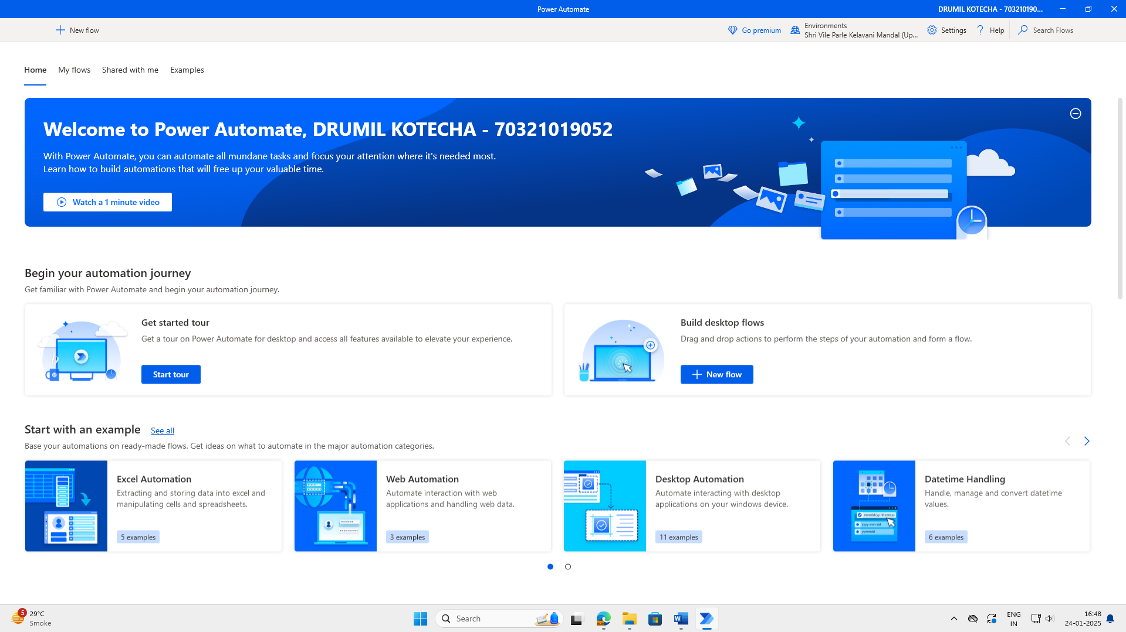

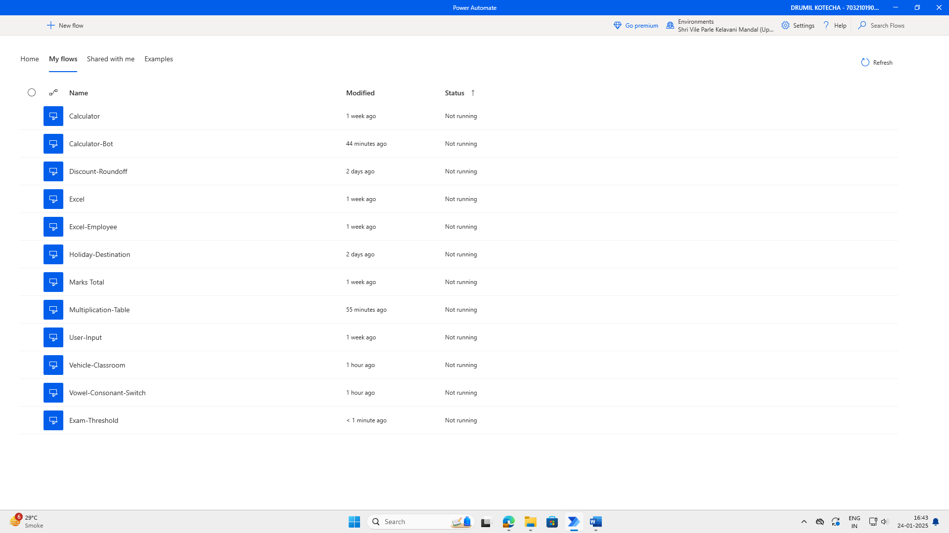

**Conclusion:**

In conclusion, I successfully completed the installation and setup of Power Automate Desktop, which provided a comprehensive understanding of its environment. Through the process, I learned how to boot up the Power Automate interface, navigate its features, and initiate new automation flows. I was able to create simple bots, such as automating tasks with lists, working with Excel files, calculating averages, and implementing conditional logic (if-else). The user-friendly interface and clear instructions made it easy to create basic automation tasks, which enhanced my understanding of Robotic Process Automation (RPA) tools and their applications. This experiment has laid a strong foundation for further exploration and development of more complex automation solutions using Power Automate.